Module 14 homework

Mason Deja

7/26/17

Hypothesis testing

1. The p-value is “the probability of observing a sample mean of 73 or less if the population mean is 80” DNR Ho.

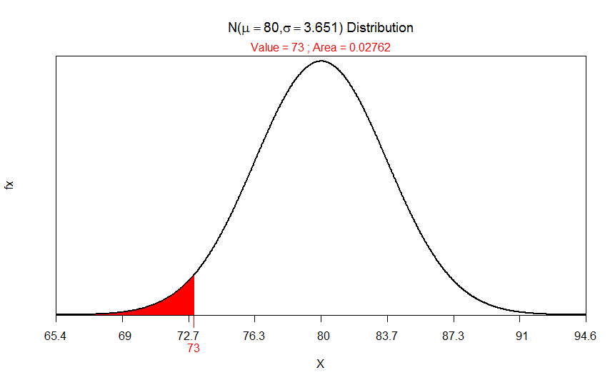

1. The p-value is “the probability of observing a sample mean of 1370 “or different” if the pop mean is 1500”. Reject HO.

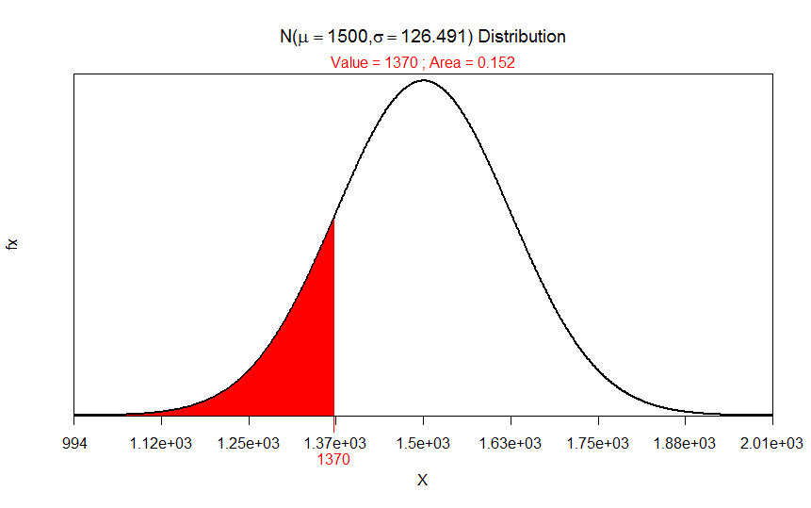

Beetle Size

1. HA:u>190 Ho:U=190(where U represents the mean thorax length of the Halticus oleacea beetle study group. Thus, the alternative hypothesis represents the increased mean thorax lengths.
2. Sample mean=194.166
3. P-value is 0.6168
4. Reject Ho because P-value(0.0.3833>0.05) is larger than a. it can be summarized that the thorax length of the *Halticus oleracea* species would be smaller than 190 mm.

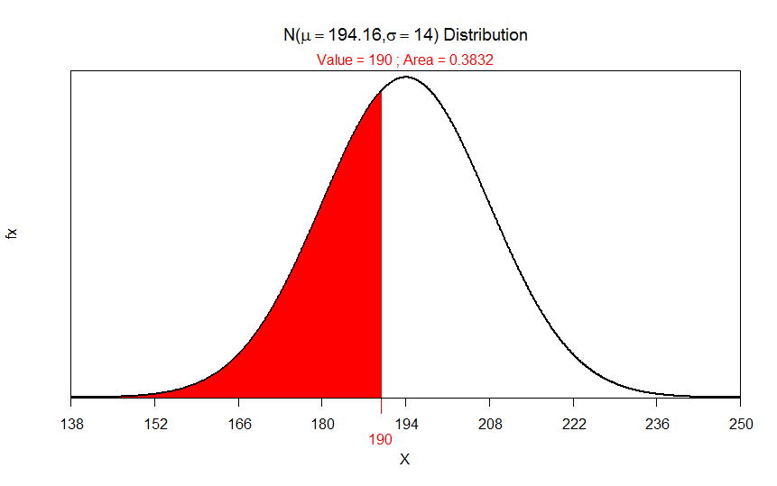

R stuff

#pvaluecalcs

library(NCStats)

distrib(73,mean=80, sd=20/sqrt(30),lower.tail = TRUE)

( 2\*distrib(1370,mean=1500,sd=800/sqrt(40),lower.tail=TRUE))

#beetles

library(NCStats)

setwd("~/R stuff")

df<-read.csv("Beetles.csv")

hc<-filterD(df,species=="Halticus.oleracea")

str(hc)

distrib(190,mean=194.16,sd=14)